A circular food economy: how to eat well and waste less

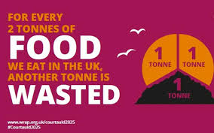

This is one of the things HGC would like to focus on this coming year and here are some useful websites if you want to learn more:
https://impact- tool.org.uk/footprint/footprint?regionId=E04004667&geography=parish&footprintType=consumption&scale=per-household)
See this website for a per-household breakdown of Hambledon’s CO2e consumption footprint. Apparently 18% of our consumption is food and diet-related!

https://www.theguardian.com/environment/ng-interactive/2015/aug/12/produced-but-never-eaten-a-visual-guide-to-food-waste
The reality of food waste!

https://friendsoftheearth.uk/food-waste
All you need to know about the issue of food waste and how to help solve the problem, including advice on planning meals, using leftovers, composting, etc.

https://lovefoodhatewaste.com
A very practical guide to cutting down on food waste and saving money in the process!

https://wrap.org.uk/about-us
This NGO is all about changing the way things are produced, consumed and disposed of. 45% of global greenhouse gas emissions can only be tackled by changing the way we make and consume products and food.

https://wrap.org.uk/taking-action/citizen-behaviour-change/love-food-hate-waste/key-campaigns/food-waste-action-week
This is all about WRAP’s Food Waste Action Week in March 2023. Watch this space and our HGC Facebook page and website for more information about things you can take part in!

https://wrap.org.uk/resources/report/tracking-uk-food-system-greenhouse-gas-emissions-2022-update
A report that reaffirms the critical role that the food system has to play in reducing greenhouse gas emissions both in the UK and overseas.

https://www.greencompostables.com/blog/plastic-free-tea-bags
Find out which teabags you can compost at home – according to the UK Tea and Infusions Association we consume 60.2 billion cups of tea per annum – so worth recycling tea bags if possible.

